**NAME: NASHRA GHAFFAR**

**ROLL NO: CT-20032**

**CCN WORKBOOK**

**LAB # 02**

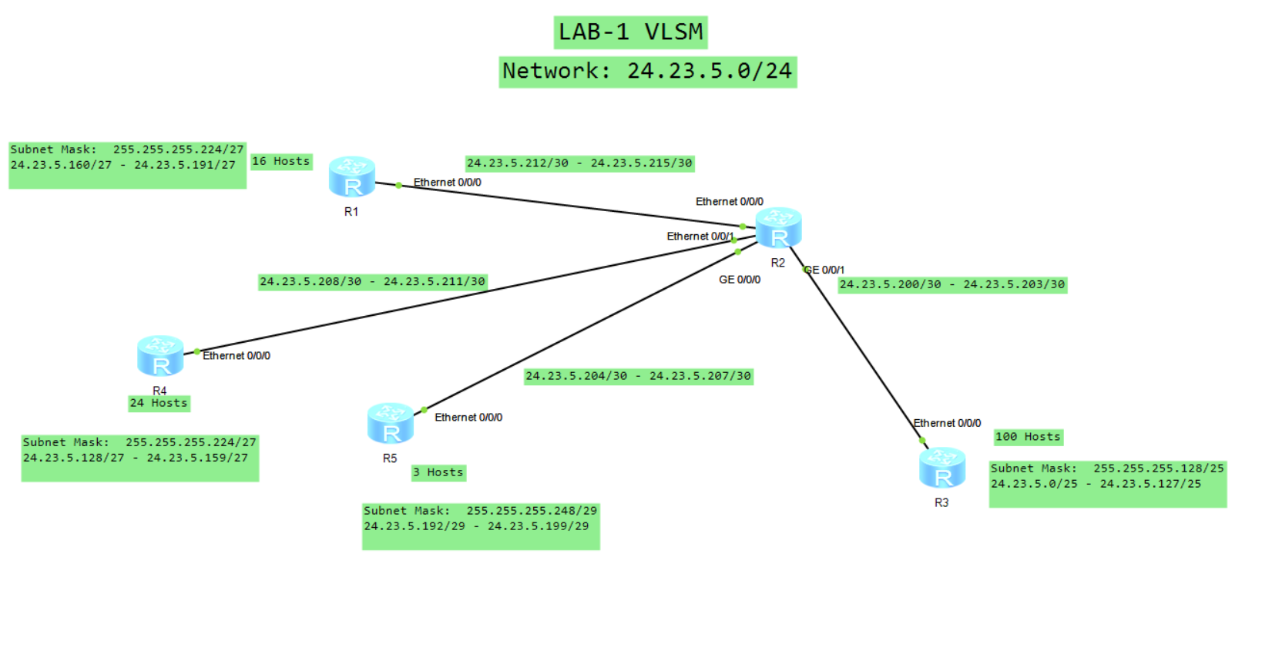

**LAB # 03**

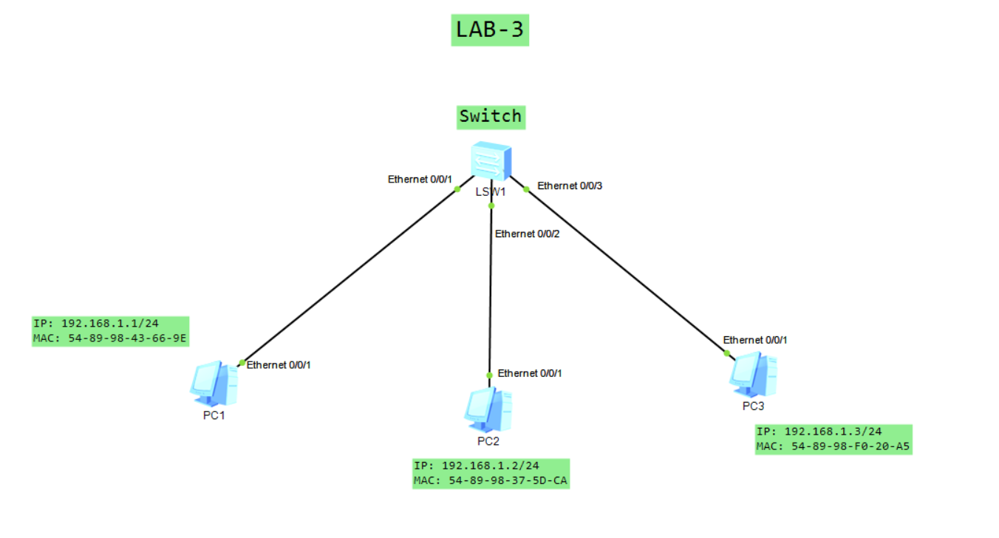

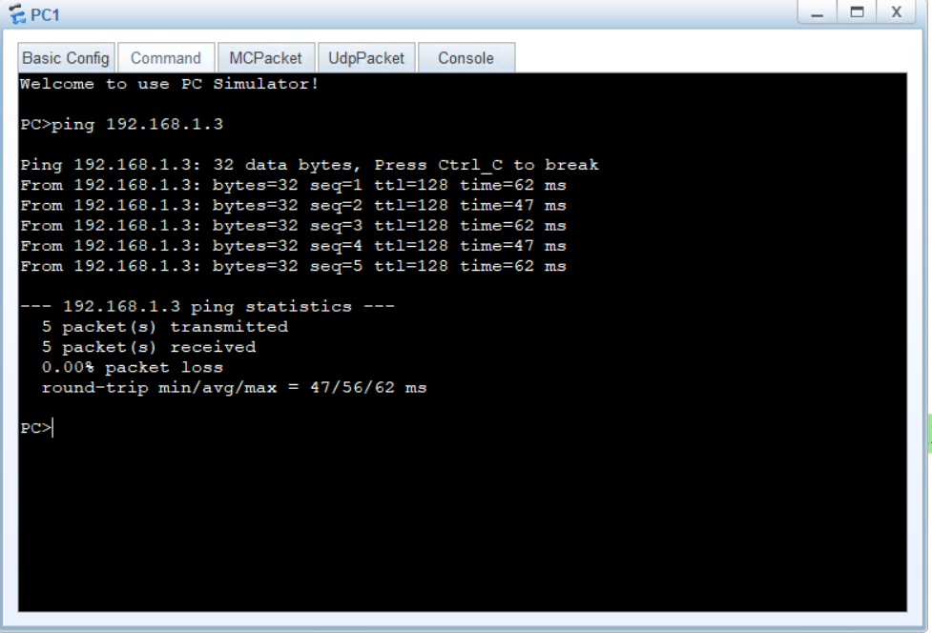

**Role of PC 2:**

When PC1 wants to ping PC3, it needs to know PC3's MAC address. Since PC1 and PC3 are not directly connected, PC1 sends an ARP request as a broadcast message, asking, "Who has the IP address 192.168.1.3? Please tell me your MAC address."

Now, PC2 plays a crucial role in this process. PC2, being on the same local network as PC1 and PC3, receives the ARP request. However, since PC2 is not the intended recipient (192.168.1.3), it does not respond to the ARP request.

Instead, PC3, the actual owner of IP address 192.168.1.3, receives the ARP request. PC3 responds directly to PC1 with its MAC address (54-89-98-F0-20-A5). PC1 then updates its ARP table with the MAC address for IP address 192.168.1.3 and uses it to send the ping request to PC3.

**Static ARP Entry:**

A static ARP entry is a manually configured mapping between an IP address and a MAC address on a device. Administrators can create static ARP entries to override the dynamic ARP resolution process. When a static ARP entry exists, the device will always use the specified MAC address for the corresponding IP address, regardless of whether it receives ARP requests.

**Dynamic ARP Entry:**

Dynamic ARP entries are automatically learned and maintained by devices on the network. When two devices communicate for the first time, they exchange ARP requests and replies to discover each other's MAC addresses. The device then adds this information to its ARP table, associating the IP address with the learned MAC address

**LAB # 04**

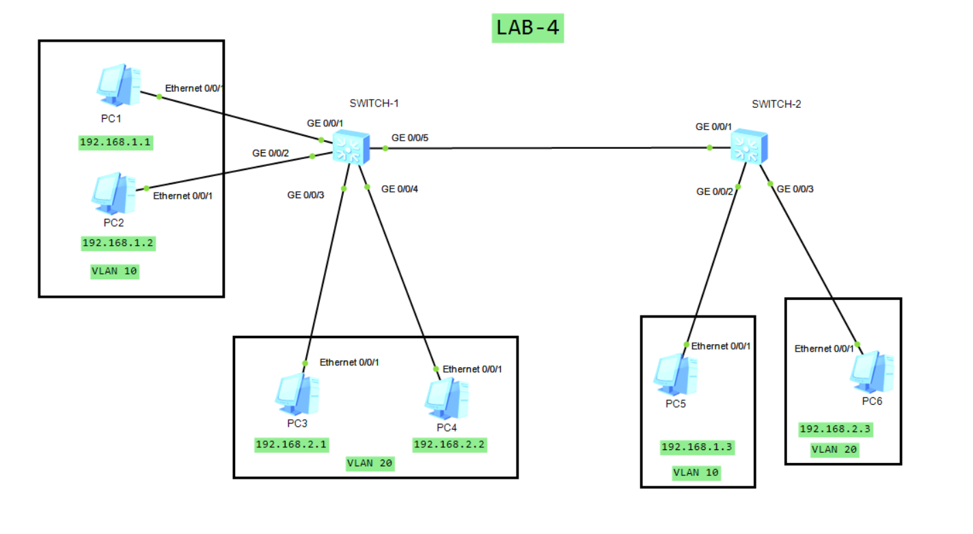

**SWITCH-1 CONFIGURATION:**

#

vlan batch 10 20

#

interface GigabitEthernet0/0/1

port link-type access

port default vlan 10

#

interface GigabitEthernet0/0/2

port link-type access

port default vlan 10

#

interface GigabitEthernet0/0/3

port link-type access

port default vlan 20

#

interface GigabitEthernet0/0/4

port link-type access

port default vlan 20

#

interface GigabitEthernet0/0/5

port link-type trunk

port trunk allow-pass vlan 10 20

#

**SWITCH-2 CONFIGURATION:**

#

vlan batch 10 20

#

interface GigabitEthernet0/0/1

port link-type trunk

port trunk allow-pass vlan 10 20

#

interface GigabitEthernet0/0/2

port link-type access

port default vlan 10

#

interface GigabitEthernet0/0/3

port link-type access

port default vlan 20

#

**LAB # 05**

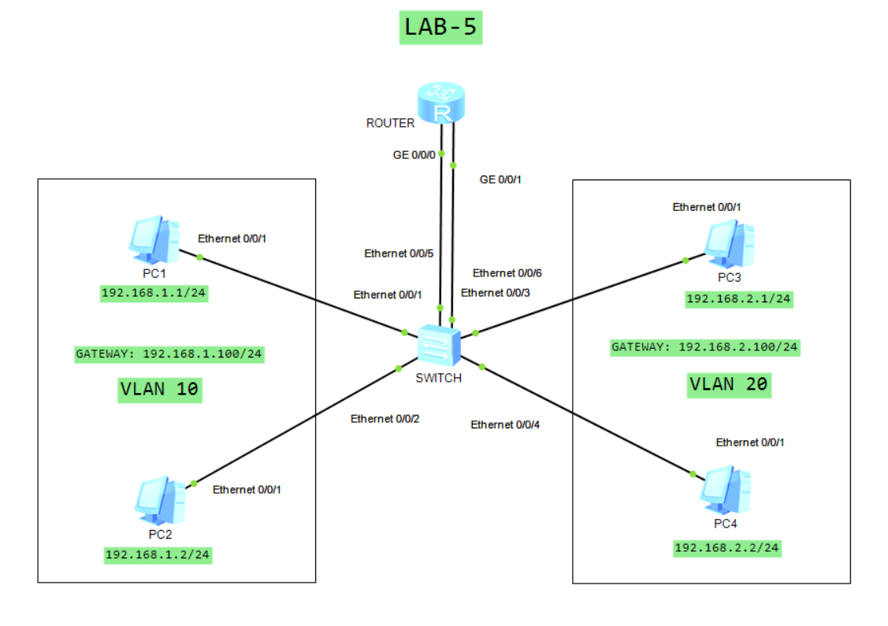

**SWITCH CONFIGURATION:**

#

vlan batch 10 20

#

interface Ethernet0/0/1

port link-type access

port default vlan 10

#

interface Ethernet0/0/2

port link-type access

port default vlan 10

#

interface Ethernet0/0/3

port link-type access

port default vlan 20

#

interface Ethernet0/0/4

port link-type access

port default vlan 20

#

interface Ethernet0/0/5

port link-type access

port default vlan 10

#

interface Ethernet0/0/6

port link-type access

port default vlan 20

#

**ROUTER CONFIGURATION:**

#

interface GigabitEthernet0/0/0

ip address 192.168.1.100 255.255.255.0

#

interface GigabitEthernet0/0/1

ip address 192.168.2.100 255.255.255.0

#

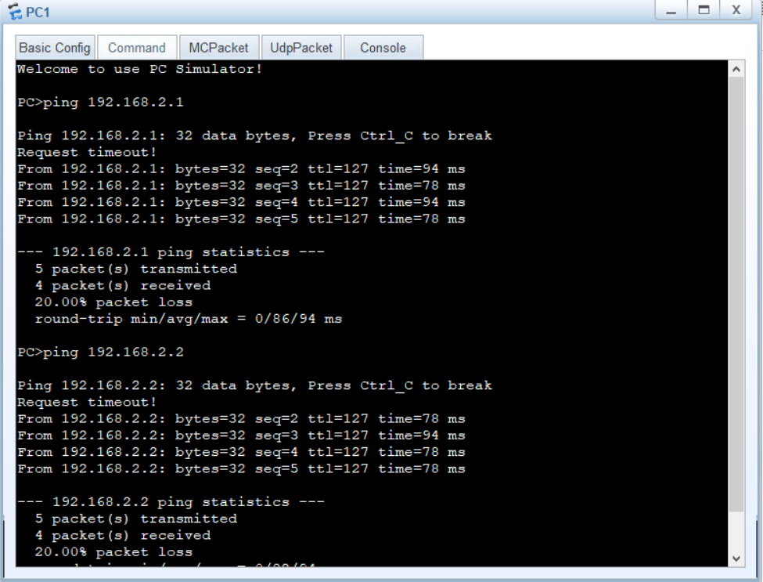

**LAB # 06**

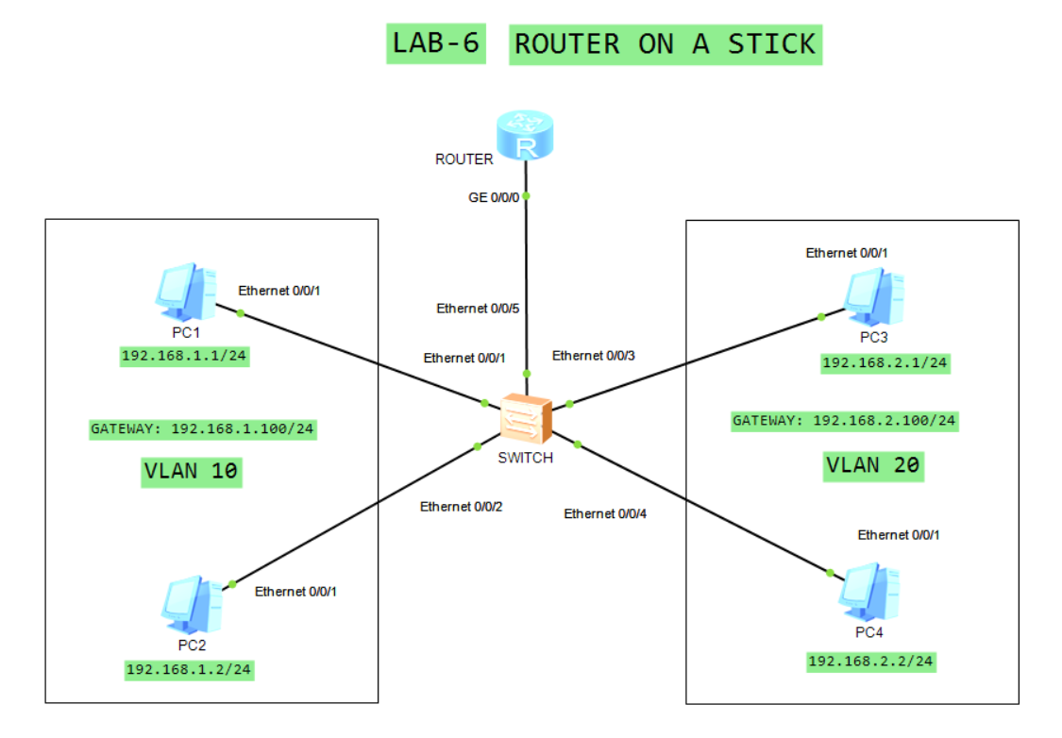

**SWITCH CONFIGURATION:**

#

vlan batch 10 20

#

interface Ethernet0/0/1

port link-type access

port default vlan 10

#

interface Ethernet0/0/2

port link-type access

port default vlan 10

#

interface Ethernet0/0/3

port link-type access

port default vlan 20

#

interface Ethernet0/0/4

port link-type access

port default vlan 20

#

interface Ethernet0/0/5

port link-type trunk

port trunk allow-pass vlan 10 20

#

**ROUTER CONFIGURATION:**

#

interface GigabitEthernet0/0/0.1

dot1q termination vid 10

ip address 192.168.1.100 255.255.255.0

arp broadcast enable

#

interface GigabitEthernet0/0/0.2

dot1q termination vid 20

ip address 192.168.2.100 255.255.255.0

arp broadcast enable

#



**LAB # 07**

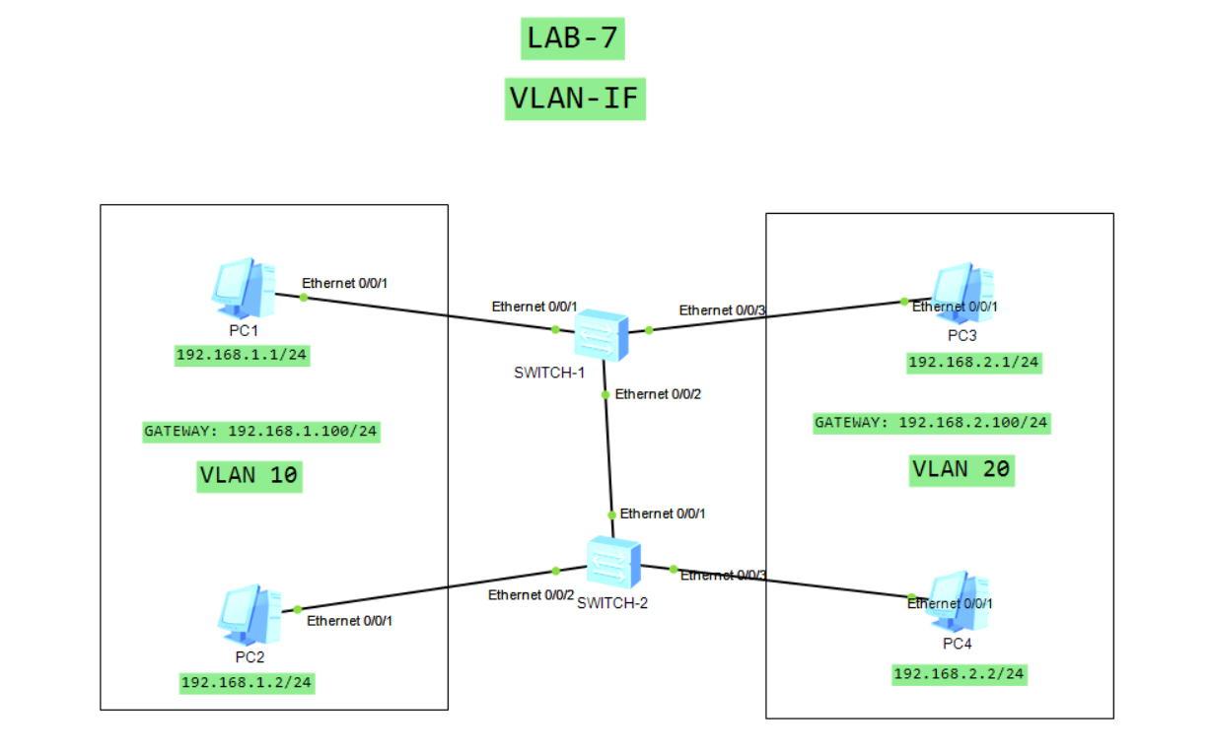

**SWITCH-1 CONFIGURATION:**

#

vlan batch 10 20

#

interface Vlanif10

ip address 192.168.1.100 255.255.255.0

#

interface Vlanif20

ip address 192.168.2.100 255.255.255.0

#

interface MEth0/0/1

#

interface Ethernet0/0/1

port link-type access

port default vlan 10

#

interface Ethernet0/0/2

port link-type trunk

port trunk allow-pass vlan 10 20

#

interface Ethernet0/0/3

port link-type access

port default vlan 20

#

**SWITCH-2 CONFIGURATION:**

#

vlan batch 10 20

#

interface Vlanif10

ip address 192.168.1.100 255.255.255.0

#

interface Vlanif20

ip address 192.168.2.100 255.255.255.0

#

#

interface Ethernet0/0/1

port link-type trunk

port trunk allow-pass vlan 10 20

#

interface Ethernet0/0/2

port link-type access

port default vlan 10

#

interface Ethernet0/0/3

port link-type access

port default vlan 20

#



**LAB # 08**

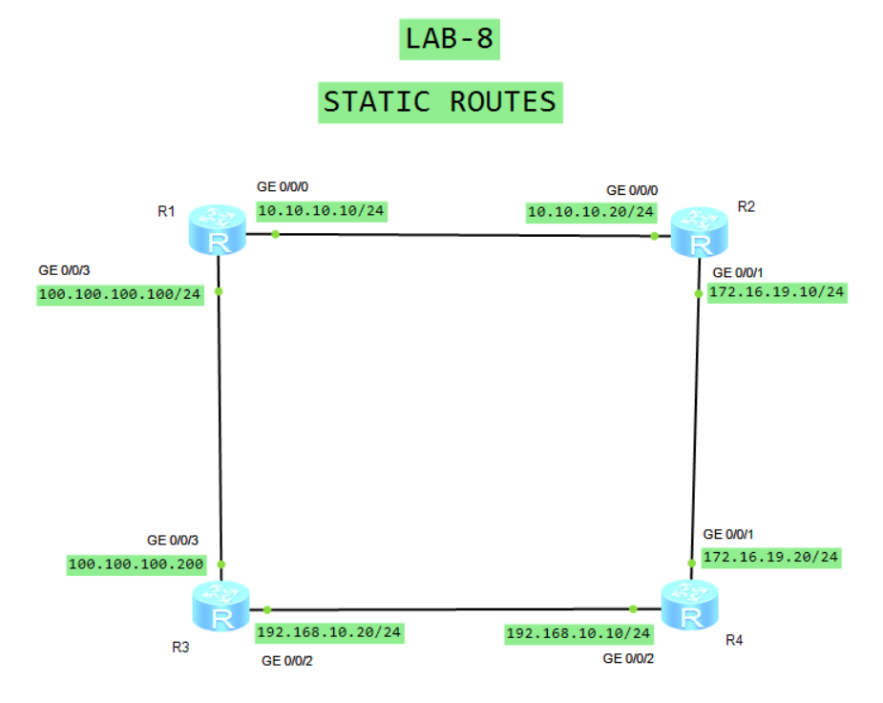

**SWITCH-1 CONFIGURATION:**

interface GigabitEthernet0/0/0

ip address 10.10.10.10 255.255.255.0

#

interface GigabitEthernet0/0/1

#

interface GigabitEthernet0/0/2

#

interface GigabitEthernet0/0/3

ip address 100.100.100.100 255.255.255.0

#

wlan

#

interface NULL0

#

ip route-static 172.16.19.0 255.255.255.0 10.10.10.20

ip route-static 192.168.10.0 255.255.255.0 100.100.100.200

ip route-static 192.168.10.0 255.255.255.0 10.10.10.20

#

**SWITCH-2 CONFIGURATION:**

#

interface GigabitEthernet0/0/0

ip address 10.10.10.20 255.255.255.0

#

interface GigabitEthernet0/0/1

ip address 172.16.19.10 255.255.255.0

#

interface GigabitEthernet0/0/2

#

interface GigabitEthernet0/0/3

#

wlan

#

interface NULL0

#

ip route-static 10.10.10.0 255.255.255.0 100.100.100.100

ip route-static 100.100.100.0 255.255.255.0 10.10.10.10

ip route-static 192.168.10.0 255.255.255.0 10.10.10.10

#

**SWITCH-3 CONFIGURATION:**

#

interface GigabitEthernet0/0/0

#

interface GigabitEthernet0/0/1

#

interface GigabitEthernet0/0/2

ip address 192.168.10.20 255.255.255.0

#

interface GigabitEthernet0/0/3

ip address 100.100.100.200 255.255.255.0

#

wlan

#

interface NULL0

#

ip route-static 10.10.10.0 255.255.255.0 100.100.100.100

ip route-static 172.16.19.0 255.255.255.0 10.10.10.20

ip route-static 172.16.19.0 255.255.255.0 100.100.100.100

#

**SWITCH-4 CONFIGURATION:**

#

interface GigabitEthernet0/0/1

ip address 172.16.19.20 255.255.255.0

#

interface GigabitEthernet0/0/2

ip address 192.168.10.10 255.255.255.0

#

interface GigabitEthernet0/0/3

#

wlan

#

interface NULL0

#

ip route-static 10.10.10.0 255.255.255.0 192.168.10.20

ip route-static 10.10.10.0 255.255.255.0 10.10.10.10

ip route-static 100.100.100.0 255.255.255.0 100.100.100.200

ip route-static 100.100.100.0 255.255.255.0 192.168.10.20

#

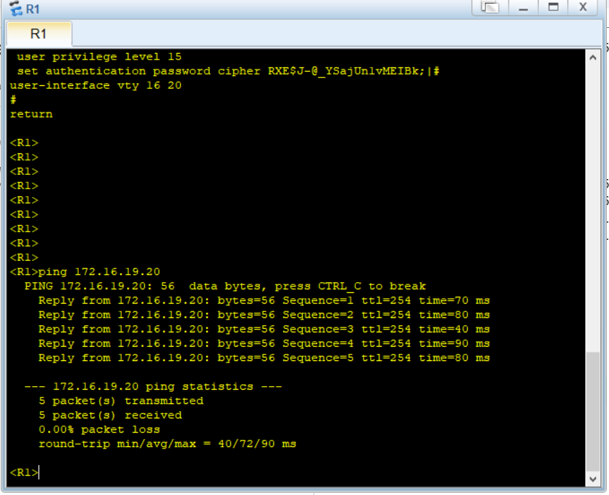

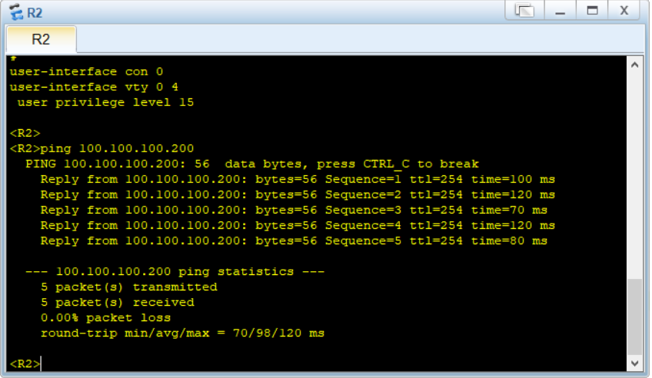

**LAB # 09**

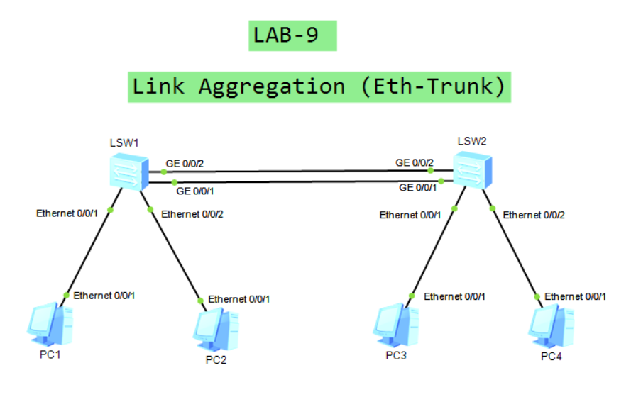

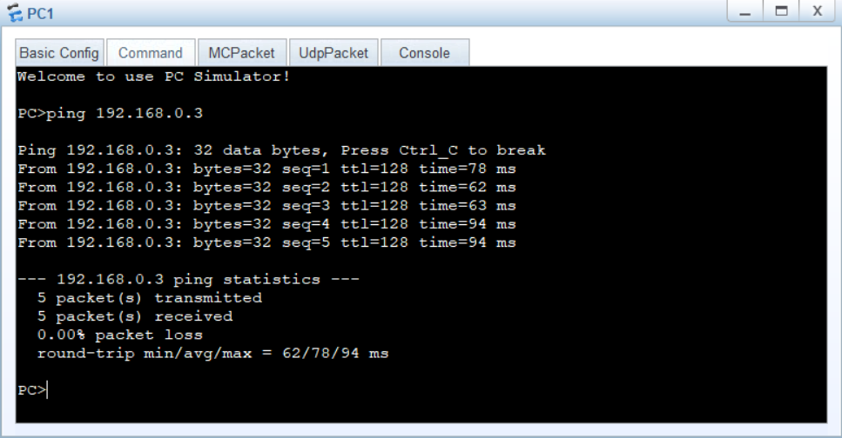

**SWITCH-1 CONFIGURATION :**

#

interface Eth-Trunk1

port link-type trunk

#

#

interface GigabitEthernet0/0/1

eth-trunk 1

#

interface GigabitEthernet0/0/2

eth-trunk 1

#

**SWITCH-2 CONFIGURATION :**

#

interface Eth-Trunk1

port link-type trunk

#

#

interface GigabitEthernet0/0/1

eth-trunk 1

#

interface GigabitEthernet0/0/2

eth-trunk 1

#

**LAB # 10**

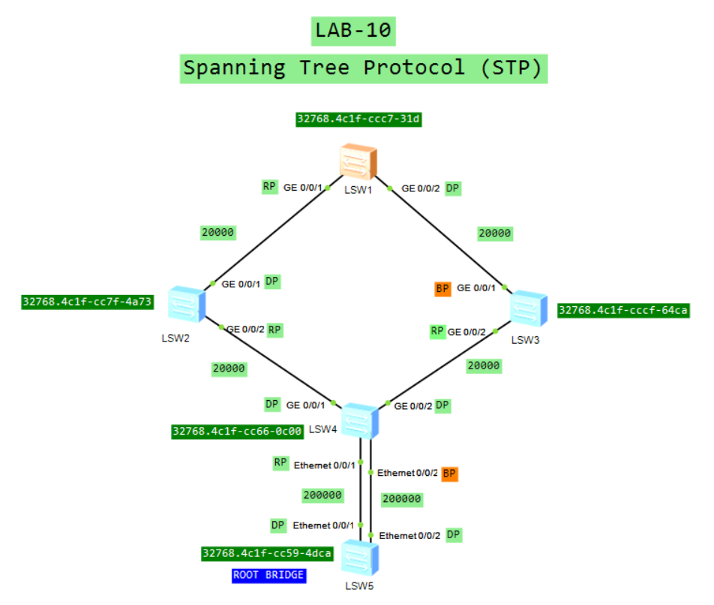

**LAB # 11**

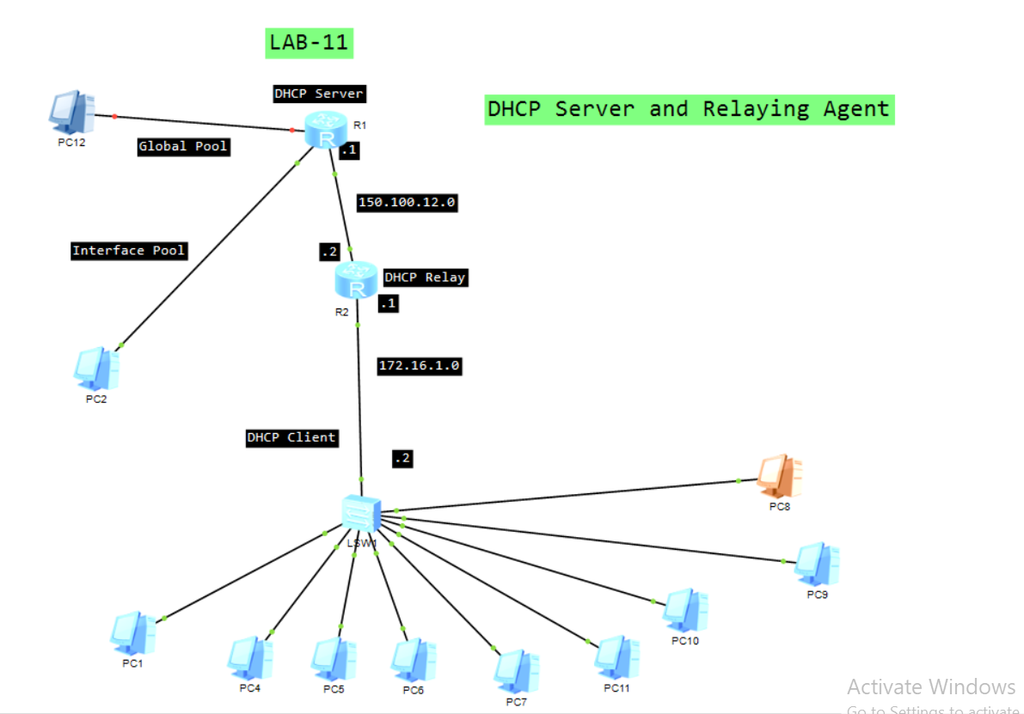

**Router R1 DHCP Server Configuration:**

dhcp enable

#

ip pool 1

gateway-list 172.16.1.1

network 172.16.1.0 mask 255.255.255.0

dns-list 150.100.15.1 150.100.15.2

domain-name neduet.edu.pk

static-bind ip-address 172.16.1.33 mac-address 5489-9860-57

2B

#

ip pool 2

gateway-list 1.1.1.1

network 1.1.1.0 mask 255.255.255.0

dns-list 1.1.1.1

#

interface Ethernet0/0/0

ip address 150.100.12.1 255.255.255.0

dhcp select global

#

interface Ethernet0/0/1

ip address 1.1.1.1 255.255.255.0

dhcp select global

#

ip route-static 172.16.1.0 255.255.255.0 150.100.12.2

**Router R2 DHCP Relay Configuration:**

dhcp enable

#

interface Ethernet0/0/0

ip address 150.100.12.2 255.255.255.0

#

interface Ethernet0/0/1

ip address 172.16.1.1 255.255.255.0

dhcp select relay

dhcp relay server-ip 150.100.12.1

**LAB # 12**

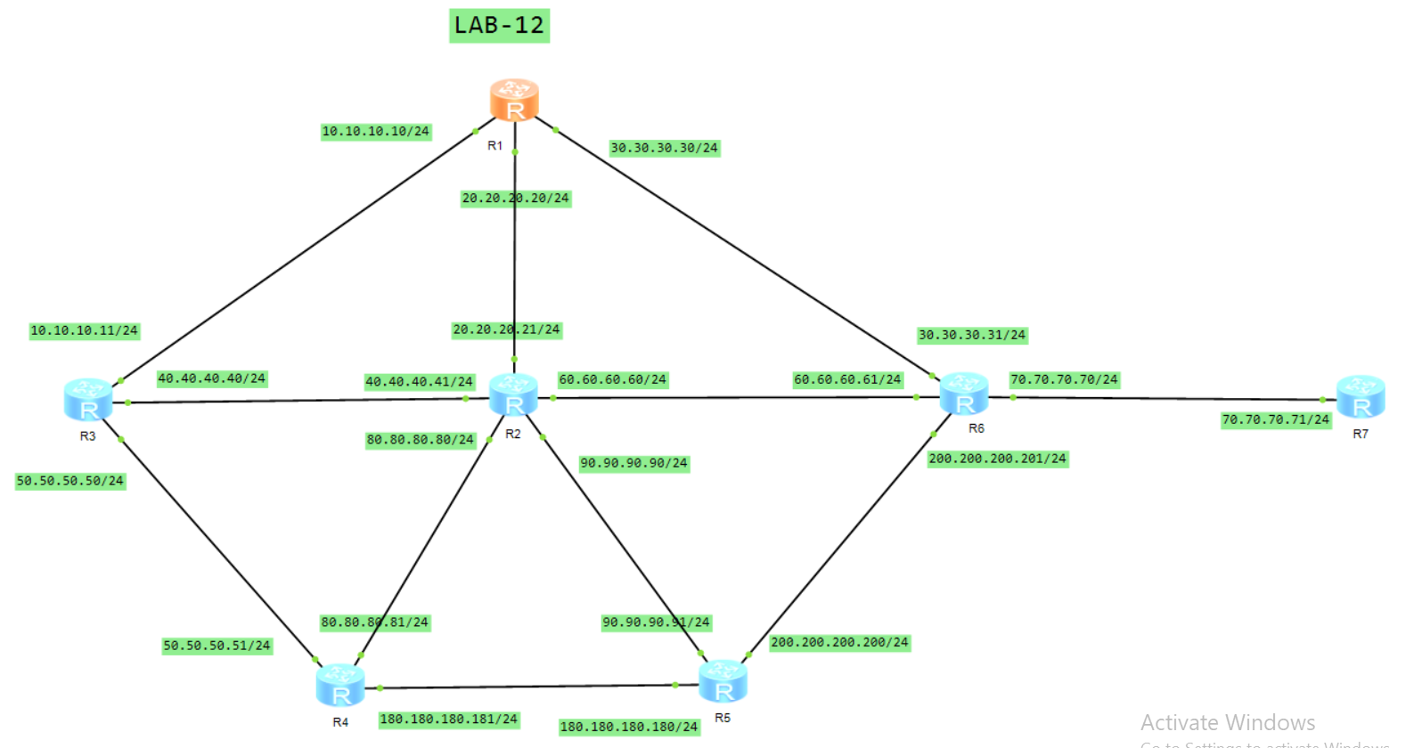

**ROUTER-1 CONFIGURATION:**

#

interface GigabitEthernet0/0/0

ip address 10.10.10.10 255.255.255.0

#

interface GigabitEthernet0/0/1

ip address 20.20.20.20 255.255.255.0

#

interface GigabitEthernet0/0/2

ip address 30.30.30.30 255.255.255.0

#

interface GigabitEthernet0/0/3

#

wlan

#

interface NULL0

#

rip 1

network 10.0.0.0

network 20.0.0.0

network 30.0.0.0

#

**ROUTER-2 CONFIGURATION:**

#

interface GigabitEthernet0/0/0

ip address 80.80.80.80 255.255.255.0

#

interface GigabitEthernet0/0/1

ip address 20.20.20.21 255.255.255.0

#

interface GigabitEthernet0/0/2

ip address 90.90.90.90 255.255.255.0

#

interface GigabitEthernet0/0/3

ip address 40.40.40.41 255.255.255.0

#

wlan

#

interface NULL0

#

rip 1

network 20.0.0.0

network 40.0.0.0

network 60.0.0.0

network 80.0.0.0

network 90.0.0.0

#

**ROUTER-3 CONFIGURATION:**

#

interface GigabitEthernet0/0/0

ip address 10.10.10.11 255.255.255.0

#

interface GigabitEthernet0/0/1

ip address 50.50.50.50 255.255.255.0

#

interface GigabitEthernet0/0/2

#

interface GigabitEthernet0/0/3

ip address 40.40.40.40 255.255.255.0

#

wlan

#

interface NULL0

#

rip 1

network 10.0.0.0

network 40.0.0.0

network 50.0.0.0

#

**ROUTER-4 CONFIGURATION:**

#

interface GigabitEthernet0/0/0

ip address 80.80.80.81 255.255.255.0

#

interface GigabitEthernet0/0/1

ip address 50.50.50.51 255.255.255.0

#

interface GigabitEthernet0/0/2

#

interface GigabitEthernet0/0/3

ip address 180.180.180.181 255.255.255.0

#

wlan

#

interface NULL0

#

rip 1

network 50.0.0.0

network 80.0.0.0

network 180.180.0.0

#

**ROUTER-5 CONFIGURATION:**

#

interface GigabitEthernet0/0/0

ip address 200.200.200.200 255.255.255.0

#

interface GigabitEthernet0/0/1

#

interface GigabitEthernet0/0/2

ip address 90.90.90.91 255.255.255.0

#

interface GigabitEthernet0/0/3

ip address 180.180.180.180 255.255.255.0

#

wlan

#

interface NULL0

#

rip 1

network 90.0.0.0

network 180.180.0.0

network 200.200.200.0

#

**ROUTER-6 CONFIGURATION:**

#

interface GigabitEthernet0/0/0

ip address 200.200.200.201 255.255.255.0

#

interface GigabitEthernet0/0/1

ip address 70.70.70.70 255.255.255.0

#

interface GigabitEthernet0/0/2

ip address 30.30.30.31 255.255.255.0

#

interface GigabitEthernet0/0/3

#

wlan

#

interface NULL0

#

rip 1

network 60.0.0.0

network 30.0.0.0

network 70.0.0.0

network 200.200.0.0

network 200.200.200.0

#

**ROUTER-7 CONFIGURATION:**

#

interface GigabitEthernet0/0/0

#

interface GigabitEthernet0/0/1

ip address 70.70.70.71 255.255.255.0

#

interface GigabitEthernet0/0/2

#

interface GigabitEthernet0/0/3

#

wlan

#

interface NULL0

#

rip 1

network 70.0.0.0

#

**LAB # 13**

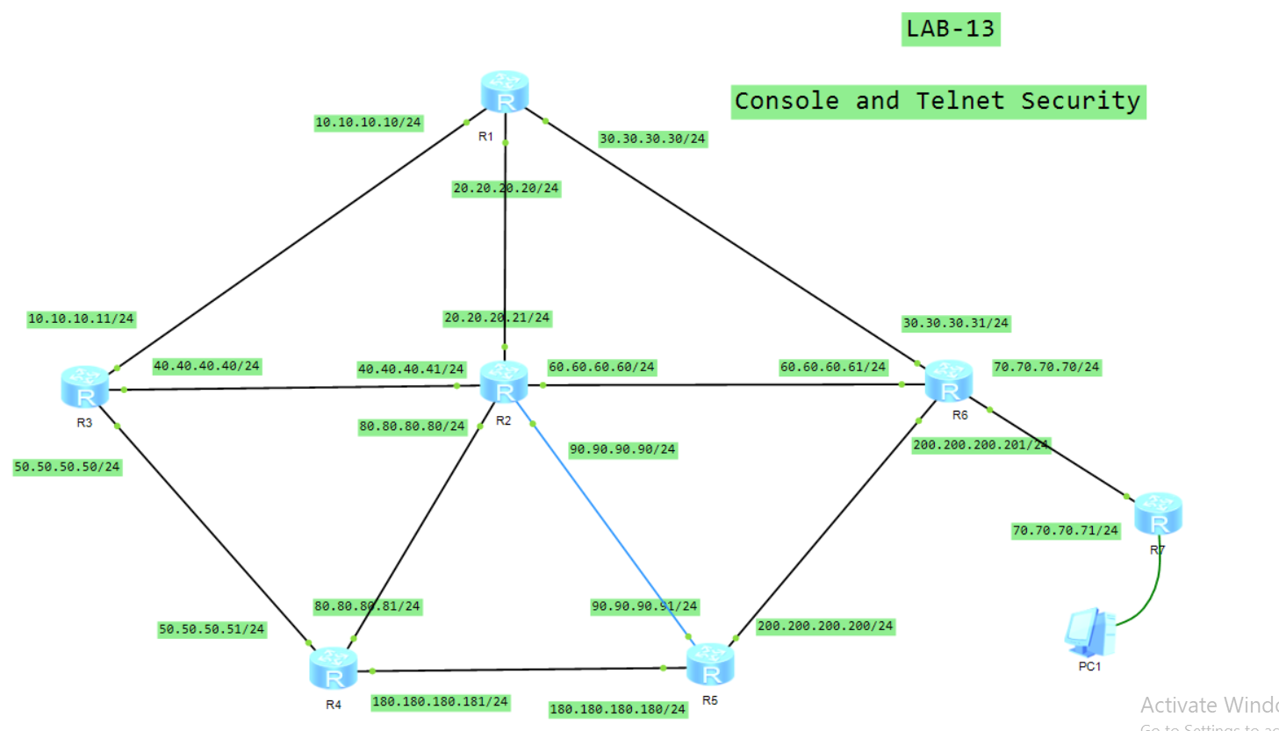

**CONFIGURATION ON ALL ROUTERS:**

#

telnet server enable

user-interface vty 0 4

authentication-mode password

userpivilege level 15

set authentication password cipher ataib123

#

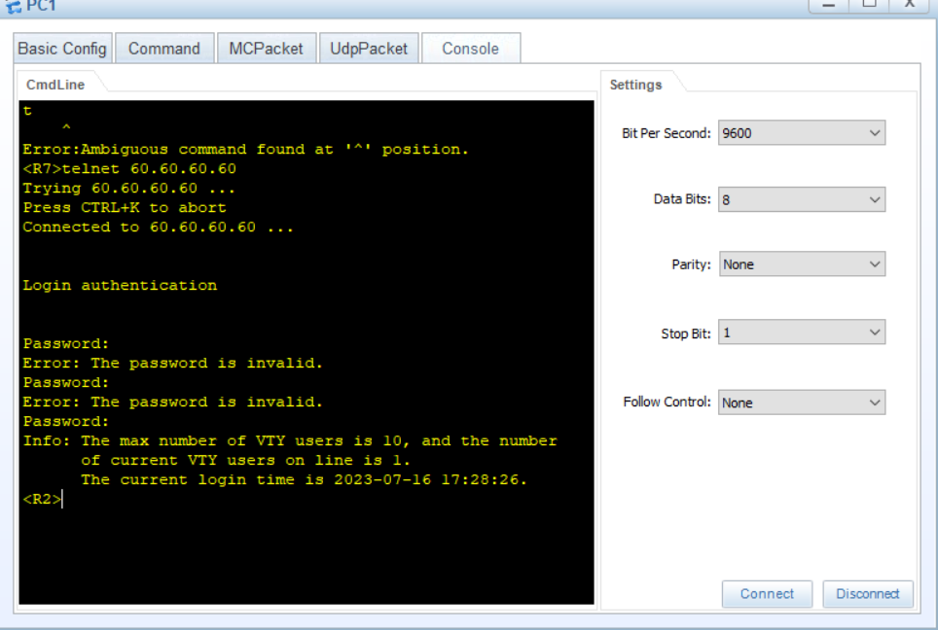

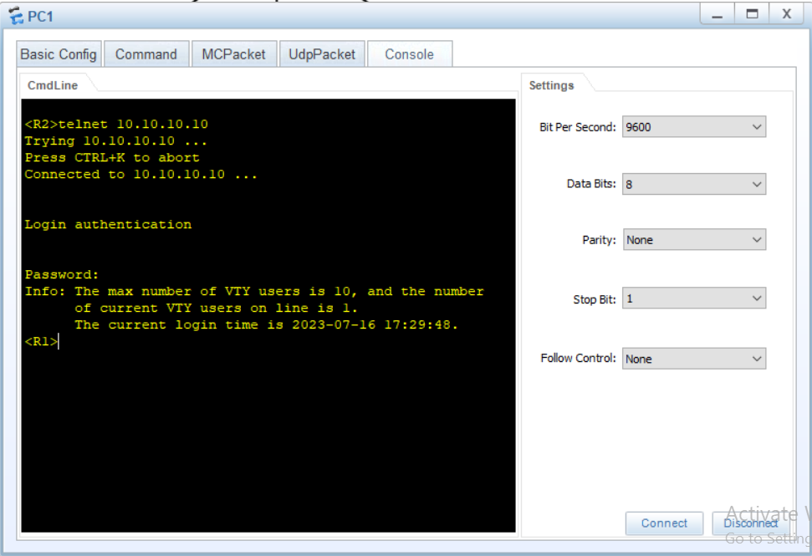

**LAB # 14**

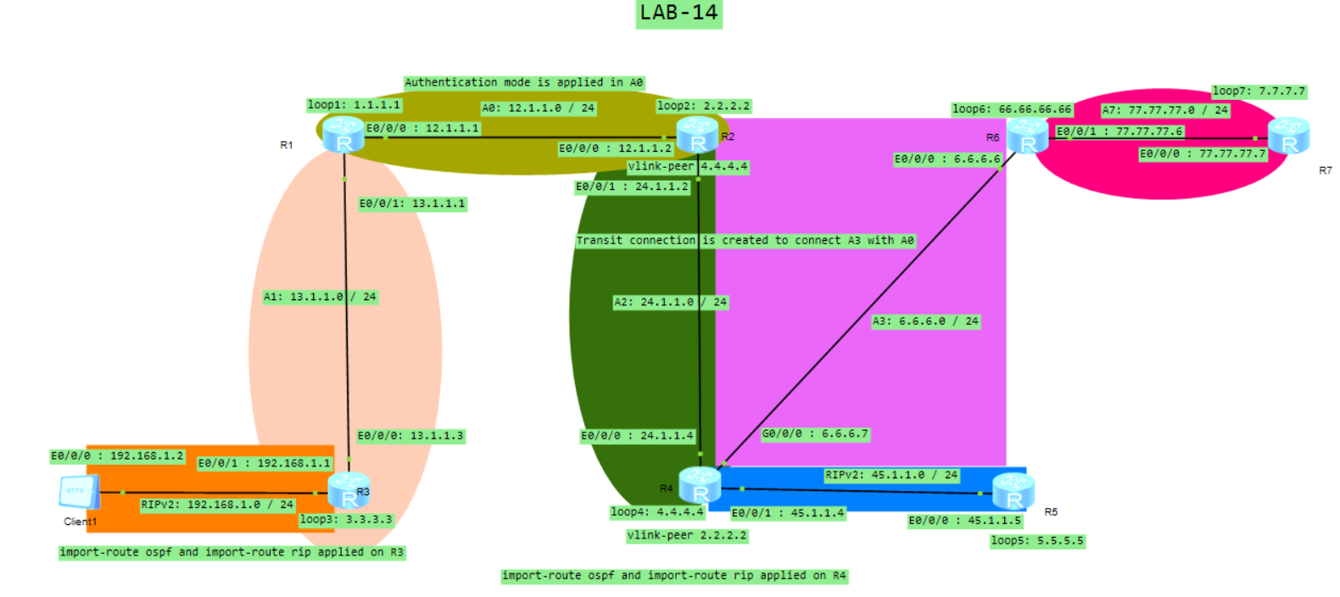

**ROUTER-1 CONFIGURATION:**

#

router id 1.1.1.1

#

interface Ethernet0/0/0

ip address 12.1.1.1 255.255.255.0

#

interface Ethernet0/0/1

ip address 13.1.1.1 255.255.255.0

#

interface LoopBack1

ip address 1.1.1.1 255.255.255.255

#

ospf 1

area 0.0.0.0

authentication-mode md5 1 cipher Tp,R+2.p*4jKUGU-KkpB'EH#

network 1.1.1.1 0.0.0.0

network 12.1.1.0 0.0.0.255

area 0.0.0.1

network 13.1.1.0 0.0.0.255

#

user-interface con 0

user-interface vty 0 4

user-interface vty 16 20

#

**ROUTER-2 CONFIGURATION:**

#

router id 2.2.2.2

#

interface Ethernet0/0/0

ip address 12.1.1.2 255.255.255.0

#

interface Ethernet0/0/1

ip address 24.1.1.2 255.255.255.0

#

interface LoopBack2

ip address 2.2.2.2 255.255.255.255

#

ospf 1

area 0.0.0.0

authentication-mode md5 1 cipher Sx^OF8POI2pe}@HMNPn@OFa#

network 2.2.2.2 0.0.0.0

network 12.1.1.0 0.0.0.255

area 0.0.0.2

network 24.1.1.0 0.0.0.255

vlink-peer 4.4.4.4

#

user-interface con 0

user-interface vty 0 4

user-interface vty 16 20

#

**ROUTER-3 CONFIGURATION:**

#

router id 3.3.3.3

#

interface Ethernet0/0/0

ip address 13.1.1.3 255.255.255.0

#

interface Ethernet0/0/1

ip address 192.168.1.1 255.255.255.0

#

interface LoopBack3

ip address 3.3.3.3 255.255.255.255

#

ospf 1

import-route rip 1

area 0.0.0.1

network 3.3.3.3 0.0.0.0

network 13.1.1.0 0.0.0.255

#

rip 1

version 2

network 192.168.1.0

import-route ospf 1

#

user-interface con 0

user-interface vty 0 4

user-interface vty 16 20

#

**ROUTER-4 CONFIGURATION:**

#

router id 4.4.4.4

#

interface Ethernet0/0/0

ip address 24.1.1.4 255.255.255.0

#

interface Ethernet0/0/1

ip address 45.1.1.4 255.255.255.0

#

interface GigabitEthernet0/0/0

ip address 6.6.6.7 255.255.255.0

#

interface LoopBack4

ip address 4.4.4.4 255.255.255.255

#

ospf 1

import-route rip 1

area 0.0.0.0

authentication-mode md5 1 cipher _.^sWI}o-G3IF$':[285/OX#

area 0.0.0.2

network 4.4.4.4 0.0.0.0

network 24.1.1.0 0.0.0.255

vlink-peer 2.2.2.2

area 0.0.0.3

network 6.6.6.0 0.0.0.255

vlink-peer 66.66.66.66

#

rip 1

version 2

network 45.0.0.0

import-route ospf 1

#

user-interface con 0

user-interface vty 0 4

user-interface vty 16 20

#

**ROUTER-5 CONFIGURATION:**

#

aaa

authentication-scheme default

authorization-scheme default

accounting-scheme default

domain default

domain default_admin

local-user admin password cipher _~f,*!}/<!ajUn1vMEIBX)P#

local-user admin service-type http

#

firewall zone Local

priority 16

#

interface Ethernet0/0/0

ip address 45.1.1.5 255.255.255.0

#

interface GigabitEthernet0/0/0

ip address 6.6.6.7 255.255.255.0

#

interface LoopBack5

ip address 5.5.5.5 255.255.255.0

#

rip 1

version 2

network 45.0.0.0

network 5.0.0.0

#

user-interface con 0

user-interface vty 0 4

user-interface vty 16 20

#

**ROUTER-6 CONFIGURATION:**

#

router id 66.66.66.66

#

interface Ethernet0/0/0

ip address 6.6.6.6 255.255.255.0

#

interface Ethernet0/0/1

ip address 77.77.77.6 255.255.255.0

#

interface LoopBack6

ip address 66.66.66.66 255.255.255.0

#

ospf 1

area 0.0.0.0

authentication-mode md5 1 cipher JNI>1sgdH+@X,k6.E\Z,@O(#

area 0.0.0.3

network 6.6.6.0 0.0.0.255

network 66.66.66.66 0.0.0.0

vlink-peer 4.4.4.4

area 0.0.0.7

network 77.77.77.0 0.0.0.255

#

user-interface con 0

user-interface vty 0 4

user-interface vty 16 20

#

**ROUTER-7 CONFIGURATION:**

aaa

authentication-scheme default

authorization-scheme default

accounting-scheme default

domain default

domain default_admin

local-user admin password cipher mdeIV<"F6,pe}@HMNPn@8)V#

local-user admin service-type http

#

interface Ethernet0/0/0

ip address 77.77.77.7 255.255.255.0

#

interface LoopBack7

ip address 7.7.7.7 255.255.255.0

#

ospf 1

area 0.0.0.7

network 7.7.7.7 0.0.0.0

network 77.77.77.0 0.0.0.255

#

user-interface con 0

user-interface vty 0 4

user-interface vty 16 20

#